NCC International Diploma
In
Computer Studies

Advance VB Assignment
Candidate name: Aamir Shahzad
NCC Candidate No:
Title: Headstones
Examination Cycle: December 2004

Candidates attempting to gain an unfair advantage or colluding in anyway whatsoever (other than on joint assignments) are liable to be disqualified. Plagiarism is an offence.

Expected candidate time allocation: 35 to 40 hours
Mark | Moderated  Marks | Final  Mark

Marker’s comment

Moderator’s comment

Table of Contents Page #

- Introduction 3
- Task 1 & 2: Read & Edit Word Document 3
- Task 3: Create Database 7
- Task 4 & 6: Database and Searching 12
- Task 5: Help Facility 17
- Task 7: System Testing 18
- Task 8: Installation Guide 18
- Task 9: Evaluation & Feed Back 19

1. Introduction
This assignment is based on the real problems that are currently being aced by groups that wish to summaries the data on headstones in order to create a computer based catalogue of information about the people who are buried in particular location.

2. Task 1 & 2: Read & Edit Word Document

2.1 Introduction
In this task we make the VB Form that reads and writes in word document, where we store the necessary information. Through the form we can open the document and store the new values through different buttons on the form.

2.2 Word document design/layout
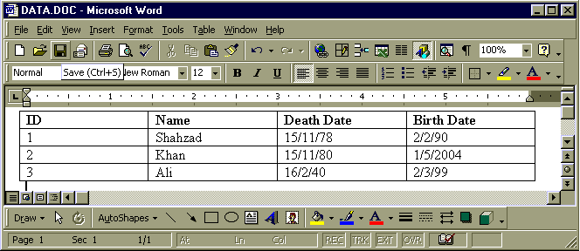

2.3 Form Design
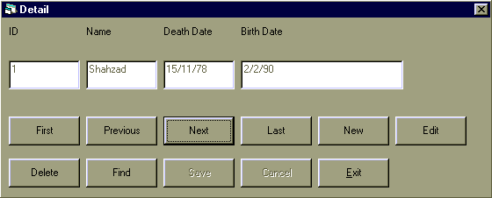

2.4 Coding
Option Explicit
Dim wdA As Word.Application, wdD As Word.Document, wdTbl As Word.Table
Dim nRow As Integer, bIsNewRec As Boolean
Private Sub cmdCancel_Click()
Call ShowData : Call LockCmd : Call LockTxt : Exit Sub
End Sub
Private Sub cmdDel_Click()
On Error GoTo Err_cmdDel_Click
If IsDataExist = True Then
Dim nResp As Integer
nResp = MsgBox("Want to Delete current record?", vbYesNo, "Delete?")
If nResp = vbYes Then
wdTbl.Rows(nRow).Delete
If nRow > wdTbl.Rows.Count Then nRow = wdTbl.Rows.Count
Call ShowData
End If
End If
Exit Sub
Err_cmdDel_Click:
MsgBox Err.Description
End Sub
Private Sub cmdEdit_Click()
Call LockTxt : Call LockCmd
End Sub
Private Sub cmdExit_Click()
On Error GoTo Err_cmdExit_Click
wdA.Visible = False : wdD.Close : wdA.Quit : Set wdA = Nothing : End
Err_cmdExit_Click:
MsgBox Err.Description
End Sub
Private Sub cmdFind_Click()
On Error GoTo Err_cmdFind_Click
Dim nR As Integer, nC As Integer, nLn As Integer, nFindVal As String
nFindVal = InputBox("Enter Roll No.", "Roll No?", 1)
If nFindVal = "" Then
Exit Sub
End If
If IsNumeric(nFindVal) Then
For nR = 2 To wdTbl.Rows.Count
For nC = 1 To wdTbl.Columns.Count
nLn = Len(wdTbl.Rows(nR).Cells(nC).Range.Text)
If CInt(nFindVal) = Mid(wdTbl.Rows(nR).Cells(nC).Range.Text, 1, nLn - 2) Then
nRow = nR
Call ShowData
Exit Sub
End If
Next nC
Next nR
MsgBox "Value not found"
Else
MsgBox "No a valid Number"
End If
Exit Sub
Err_cmdFind_Click:
MsgBox Err.Description
End Sub
Private Sub cmdFirst_Click()
nRow = 2 : Call ShowData
End Sub
Private Sub cmdLast_Click()
nRow = wdTbl.Rows.Count : Call ShowData
End Sub
Private Sub cmdNew_Click()
Call EmptyTxt : Call LockCmd : Call LockTxt : bIsNewRec = True
End Sub
Private Sub cmdNext_Click()
If nRow >= wdTbl.Rows.Count Then
MsgBox "You are at the end!", vbCritical
Exit Sub
End If
nRow = nRow + 1 : Call ShowData
End Sub
Private Sub cmdPrev_Click()
If nRow <= 2 Then
MsgBox "You are at the start", vbCritical
Exit Sub
End If
nRow = nRow – 1 : Call ShowData
End Sub
Private Sub cmdSave_Click()
Call LockTxt
If bIsNewRec = True Then
Selection.EndKey wdStory
Selection.MoveUp wdLine
Selection.InsertRowsBelow 1
bIsNewRec = False
nRow = wdTbl.Rows.Count
End If
Dim nCol As Integer
For nCol = 1 To wdTbl.Columns.Count
wdTbl.Rows(nRow).Cells(nCol).Range.Text = txtData(nCol - 1)
Next nCol
Call ShowData : Call LockCmd
End Sub
Private Sub Form_Load()
On Error GoTo Err_Form_Load
bIsNewRec = False
Set wdA = New Word.Application
Set wdD = wdA.Application.Documents.Open(App.Path & "\data.doc")
Set wdTbl = wdD.Tables(1)
nRow = 1 : Call ShowHeader
nRow = 2 : Call ShowData
Exit Sub
Err_Form_Load:
MsgBox Err.Description
End Sub
Private Sub ShowData()
If IsDataExist = True Then
Dim nC As Integer
Dim nLn As Integer
Dim sStr As String
For nC = 1 To wdTbl.Columns.Count
sStr = wdTbl.Rows(nRow).Cells(nC).Range.Text
nLn = Len(sStr)
txtData(nC - 1) = Mid(sStr, 1, nLn - 2)
Next nC
End If
End Sub
Private Sub ShowHeader()
Dim nC As Integer
Dim nLn As Integer
For nC = 1 To wdTbl.Columns.Count
nLn = Len(wdTbl.Rows(nRow).Cells(nC).Range.Text)
lblHeader(nC - 1) = Mid(wdTbl.Rows(nRow).Cells(nC).Range.Text, 1, nLn - 2)
Next nC
End Sub
Private Sub EmptyTxt()
Dim L As Byte
For L = 0 To 3
txtData(L) = ""
Next L
End Sub
Private Sub LockCmd()
cmdPrev.Enabled = Not cmdPrev.Enabled
cmdNext.Enabled = Not cmdNext.Enabled
cmdExit.Enabled = Not cmdExit.Enabled
cmdNew.Enabled = Not cmdNew.Enabled
cmdSave.Enabled = Not cmdSave.Enabled
cmdCancel.Enabled = Not cmdCancel.Enabled
cmdFirst.Enabled = Not cmdFirst.Enabled
cmdLast.Enabled = Not cmdLast.Enabled
cmdDel.Enabled = Not cmdDel.Enabled
cmdFind.Enabled = Not cmdFind.Enabled
cmdEdit.Enabled = Not cmdEdit.Enabled
End Sub
Private Sub LockTxt()
Dim L As Byte
For L = 0 To 3
txtData(L).Enabled = Not txtData(L).Enabled
Next L
End Sub
Private Function IsDataExist() As Boolean
If wdTbl.Rows.Count <= 1 Then
MsgBox "No record found"
IsDataExist = False
Else
IsDataExist = True
End If
End Function

3. Task 3: Create Database

3.1 Introduction
This task is about creating such a VB-Form that is capable of creating database, table, fields and its indexes.

3.2 Form Design
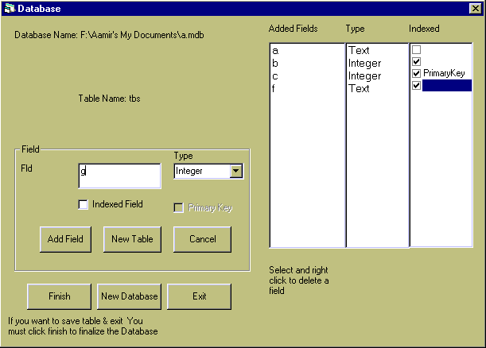

3.3 Coding
Option Explicit

Dim Ws As DAO.Workspace, Db As DAO.Database, Tbl As DAO.TableDef
Dim Fld As DAO.Field, Ind As DAO.Index
Private Sub chkIndex_Click()
chkPk.Enabled = Not chkPk.Enabled
End Sub
Private Sub cmdAddFld_Click()
If txtFld.Text = "" Then
MsgBox "Enter field name"
Exit Sub
End If
Dim Lv As Integer
If lstFld.ListCount > 0 Then
For Lv = 0 To lstFld.ListCount - 1
If txtFld.Text = lstFld.List(Lv) Then
MsgBox "You already have a field name " & txtFld
Exit Sub
End If
If lstInd.List(Lv) = "PrimaryKey" And chkPk.Value = vbChecked Then
MsgBox "Primary Key already defined"
Exit Sub
End If
Next Lv
End If
Set Fld = Tbl.CreateField(txtFld, cboType.ItemData(cboType.ListIndex))
txtFld.SetFocus
Tbl.Fields.Append Fld
lstFld.AddItem txtFld
lstType.AddItem cboType.Text
lstInd.AddItem " "
If chkIndex.Value = vbChecked Then
Set Ind = Tbl.CreateIndex(txtFld)
Set Fld = Ind.CreateField(txtFld, cboType.ItemData(cboType.ListIndex))
Ind.Fields.Append Fld
lstInd.Selected(lstInd.NewIndex) = True
Ind.Primary = IIf(chkPk.Value, True, False)
If Ind.Primary = True Then
lstInd.List(lstInd.NewIndex) = "PrimaryKey"
chkPk.Value = vbUnchecked
'chkPk.Enabled = False
End If
Tbl.Indexes.Append Ind
End If
txtFld = ""
chkIndex.Value = vbUnchecked
End Sub
Private Sub cmdCancel_Click()
cmdFinish.Enabled = False
fraFld.Visible = False
fraTbl.Visible = True
txtTbl = ""
txtTbl.SetFocus
fraTbl.Caption = "Table"
lstFld.Clear
lstType.Clear
lstInd.Clear
End Sub
Private Sub cmdCreateDb_Click()
On Error GoTo Err_Db
cdlSave.Filter = "MS-Access Database Files|*.mdb"
cdlSave.ShowSave
If cdlSave.FileName <> "" And Right(cdlSave.FileName, 4) <> ".mdb" Then
MsgBox "There should be no file extention OR only 'mdb' file extention is allowed"
Exit Sub
End If
If cdlSave.FileName <> "" Then
Set Ws = DBEngine.Workspaces(0)
Set Db = Ws.CreateDatabase(cdlSave.FileName, dbLangGeneral)
FraDb.Visible = False
fraTbl.Visible = True
lblDb.Caption = "Database Name: " & cdlSave.FileName
txtTbl.SetFocus
End If
Exit Sub
Err_Db:
Select Case Err.Number
Case 3204
Dim nResp As Long
nResp = MsgBox("Database already exists. Delete it or no", vbYesNo)
If nResp = vbYes Then
Kill (cdlSave.FileName) '& ".mdb")
Resume
End If
End Select
End Sub
Private Sub cmdCreateTbl_Click()
If txtTbl.Text = "" Then
MsgBox "Enter Table name"
Exit Sub
End If
Dim Lv As Integer
For Lv = 0 To Db.TableDefs.Count - 1
'MsgBox Db.TableDefs(Lv).Name
If txtTbl.Text = Db.TableDefs(Lv).Name Then
MsgBox "Table already exits!", vbCritical
Exit Sub
End If
Next Lv
Set Tbl = Db.CreateTableDef(txtTbl)
fraTbl.Visible = False
fraFld.Visible = True
cmdFinish.Enabled = True
cmdNewDb.Enabled = True
txtFld.SetFocus
lblTbl.Caption = "Table Name: " & txtTbl
lblTbl.Visible = True
End Sub
Private Sub cmdExit_Click()
End
End Sub
Private Sub cmdFinish_Click()
On Error GoTo Err_NoFld
Db.TableDefs.Append Tbl
End
Err_NoFld:
Select Case Err.Number
Case 3264
MsgBox "Add at least one field"
Case Else
MsgBox "An error occures i.e " & Err.Description
End Select
End Sub
Private Sub cmdNewDb_Click()
On Error GoTo Err_NewDb
lblTbl.Visible = False
Db.TableDefs.Append Tbl
Ws.Close
FraDb.Visible = True
fraTbl.Visible = False
fraFld.Visible = False
cmdFinish.Enabled = False
cmdNewDb.Enabled = False
txtTbl = ""
FraDb.Caption = "Database"
Exit Sub
Err_NewDb:
Select Case Err.Number
Case 3264
MsgBox "Add at least one field"
Case Else
MsgBox "An error occures i.e " & Err.Description
End Select
End Sub
Private Sub cmdNewTbl_Click()
On Error GoTo Err_NewTbl
Db.TableDefs.Append Tbl
cmdFinish.Enabled = False
fraFld.Visible = False
fraTbl.Visible = True
txtTbl = ""
txtTbl.SetFocus
fraTbl.Caption = "Table"
lstFld.Clear
lstType.Clear
lstInd.Clear
Exit Sub
Err_NewTbl:
Select Case Err.Number
Case 3264
MsgBox "Add at least one field"
Case Else
MsgBox "An error occures i.e " & Err.Description
End Select
End Sub
Private Sub Form_Load()
cboType.AddItem "Text"
cboType.ItemData(0) = 10
cboType.AddItem "Integer"
cboType.ItemData(1) = 3
cboType.ListIndex = 0
End Sub
Private Sub lstFld_MouseDown(Button As Integer, Shift As Integer, X As Single, Y As Single)
If Button = vbRightButton Then
PopupMenu mnuDel
End If
End Sub
Private Sub mnuDelFld_Click()
If lstFld.ListIndex > -1 Then
Tbl.Fields.Delete lstFld.List(lstFld.ListIndex)
MsgBox lstFld.List(lstFld.ListIndex) & ", Field is deleted"
If lstInd.Selected(lstFld.ListIndex) = True Then
Tbl.Indexes.Delete lstFld.List(lstFld.ListIndex)
End If
lstInd.RemoveItem lstFld.ListIndex
lstType.RemoveItem lstFld.ListIndex
lstFld.RemoveItem lstFld.ListIndex
Else
MsgBox "First select a field"
End If
End Sub

4. Task 4 & 6: Database and Searching

4.1 Introduction
This task is about creating a special searching form that enable user to search on different criteria bases e.g. criteria on two or more fields.

4.2 Form Design

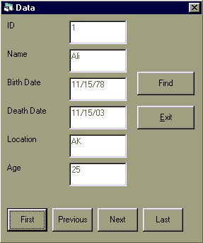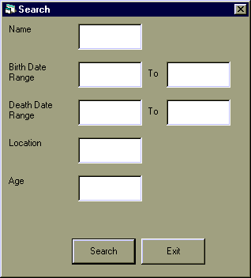

4.3 Coding

4.3.1 MDI Form Coding
Option Explicit
Private Sub mnuExit_Click()
End
End Sub
Private Sub mnuHF_Click()
frmHelp.Show
End Sub
Private Sub mnuSDF_Click()
frmData.Show
End Sub
Private Sub mnuSSF_Click()
frmFind.Show
End Sub

4.3.2 Data Form Coding
Option Explicit
Public Con As ADODB.Connection
Public Rs As ADODB.Recordset
Dim AP As Long
Public Sub DbOpen(ByVal strPath As String)
On Error GoTo Err_DbOpen
Set Con = New ADODB.Connection
Con.ConnectionString = "Provider=Microsoft.Jet.oledb.4.0;Data Source=" & strPath _ & "\Data.mdb"
Con.Open
Set Rs = New ADODB.Recordset
Dim strSQL As String
strSQL = "SELECT Data.*, (DateDiff(""yyyy"",[BirthDate],[DeathDate])) AS Age " _
& "FROM Data;"
Rs.Open strSQL, Con, adOpenKeyset, adLockOptimistic
Exit Sub
Err_DbOpen:
MsgBox Err.Description
End Sub
Public Sub mFirst()
Rs.MoveFirst
Call ShowData
End Sub
Public Sub mNext()
Rs.MoveNext
If Rs.EOF Then
Rs.MoveLast
End If
Call ShowData
End Sub
Public Sub mPrev()
Rs.MovePrevious
If Rs.BOF Then
Rs.MoveFirst
End If
Call ShowData
End Sub
Public Sub mLast()
Rs.MoveLast
Call ShowData
End Sub
Public Sub ShowData()
Dim L As Integer
For L = 0 To 5
txtData(L) = Rs(L)
Next
'txtData(4) = DateDiff("yyyy", txtData(2), txtData(3))
End Sub
Public Sub cmdCancelFind_Click()
Rs.Close
Dim strSQL As String
strSQL = "SELECT Data.*, (DateDiff(""yyyy"",[BirthDate],[DeathDate])) AS Age " _
& "FROM Data;"
Rs.Open strSQL, Con, adOpenKeyset, adLockOptimistic
Call ShowData
Call SwitchFind
End Sub
Private Sub cmdExit_Click()
Unload Me
End Sub
Private Sub cmdFind_Click()
frmFind.Show
End Sub
Public Sub SwitchFind()
cmdFind.Visible = Not cmdFind.Visible
cmdCancelFind.Visible = Not cmdCancelFind.Visible
End Sub
Private Sub cmdFirst_Click()
Call mFirst
End Sub
Private Sub cmdHelp_Click()
frmHelp.Show
frmHelp.WebBrowser1.Navigate App.Path & "\help.htm#frmData"
End Sub
Private Sub cmdLast_Click()
Call mLast
End Sub
Private Sub cmdNext_Click()
Call mNext
End Sub
Private Sub cmdPrev_Click()
Call mPrev
End Sub
Private Sub Form_Load()
Call DbOpen(App.Path)
Call ShowData
End Sub

4.3.3 Search Form Coding
Option Explicit
Private Sub cmdExit_Click()
Call frmData.cmdCancelFind_Click
'Call frmData.ShowData
Call frmData.SwitchFind
Unload Me
End Sub
Private Sub cmdHelp_Click()
frmHelp.Show
frmHelp.WebBrowser1.Navigate App.Path & "\help.htm#frmSearch"
End Sub
Private Sub cmdSearch_Click()
frmData.Show
Dim strSQL As String
strSQL = ""
If txtName <> "" Then
strSQL = "Name = '" & txtName & "'"
End If
If IsDate(txtBirthDateStart) Then
If strSQL <> "" Then
strSQL = strSQL & " AND "
End If
strSQL = strSQL & "BirthDate >= #" & txtBirthDateStart & "#"
End If
If IsDate(txtBirthDateEnd) Then
If strSQL <> "" Then
strSQL = strSQL & " AND "
End If
strSQL = strSQL & "BirthDate <= #" & txtBirthDateEnd & "#"
End If
If IsDate(txtDeathDateStart) Then
If strSQL <> "" Then
strSQL = strSQL & " AND "
End If
strSQL = strSQL & "DeathDate >= #" & txtDeathDateStart & "#"
End If
If IsDate(txtDeathDateEnd) Then
If strSQL <> "" Then
strSQL = strSQL & " AND "
End If
strSQL = strSQL & "DeathDate <= #" & txtDeathDateEnd & "#"
End If
If txtLoc <> "" Then
If strSQL <> "" Then
strSQL = strSQL & " AND "
End If
strSQL = strSQL & "Location = '" & txtLoc & "'"
End If
If txtAge <> "" Then
If strSQL <> "" Then
strSQL = strSQL & " AND "
End If
strSQL = strSQL & "DateDiff(""yyyy"",[BirthDate],[DeathDate])= " & txtAge
End If
If strSQL <> "" Then
strSQL = " WHERE " & strSQL
End If
frmData.Rs.Close
frmData.Rs.Open "SELECT Data.*, (DateDiff(""yyyy"",[BirthDate],[DeathDate])) “ _ & “AS Age FROM Data" & strSQL, frmData.Con, adOpenKeyset, adLockOptimistic
If frmData.Rs.EOF Then
MsgBox "No Record Found"
Else
Call frmData.ShowData
Call frmData.SwitchFind
Unload Me
End If
End Sub

5. Task 5: Help Facility

5.1 Introduction
This task is about creating a help facility that is integrated with your project as well as with forms of your project.

5.2 Form Design
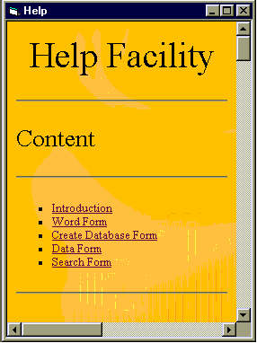

5.3 Coding
Option Explicit
Private Sub Form_Load()
WebBrowser1.Navigate App.Path & "\help.htm"
End Sub
Private Sub Form_Resize()
WebBrowser1.Width = Me.ScaleWidth
WebBrowser1.Height = Me.ScaleHeight
End Sub

6. Task 7: System Testing

6.1 Introduction
This task is about carrying out a system testing on different criteria.

6.2 Test ID
FRMSEARCH

6.3 Purpose
The purpose of this text is ensure that the. Query is working properly

6.4 Conditions/Criteria (Based on Search Form Fields) & Test data
ID | Conditions/Criteria | Test Data
1 | Name | Ali
2 | Birth Date Range | 11/15/78 to 11/16/78
3 | Death Date Range | 11/15/02 to 11/16/03
4 | Location | AK
5 | Age | 25

6.5 Expected/Actual outcome
ID | Expected outcome | Actual outcome
1 | Ali’s Record | Ali’s Record
2 | Records death date between 11/15/78 to 11/16/78 | Records death date between 11/15/78 to 11/16/78
3 | Records birth date between 11/15/78 to 11/16/78 | Records birth date between 11/15/78 to 11/16/78
4 | Records location ‘AK’ | Records location ‘AK’
5 | Records with age of 25 | Records with age of 25

7. Task 8: Installation Guide

7.1 Introduction
This task is about creating a user manual for installation guide

7.2 Installation Guide
- First of all a you need to move your control on the folder where installation setup is placed
- Click Setup.exe
- A welcome screen will be open. Click ok to start installation
- Select the Drive & Folder where you want to install the software OR click the start button to install on default Folder
- Choose Program Group. Default is your software project name. Then click ok and software will be installed on your machine

7.3 Running/Closing program
- Now run the software by clicking Start→Programs→Software project name Program group→and your Software project name file
- Now program will be open
- For closing program, Click File→Exit

8. Task 9: Evaluation & Feed Back

8.1 Introduction
This task is about evaluating your system with feed back from 3rd party.

8.2 System Evaluation
We create this assignment step by step. First of all we did a task of reading/writing/finding into a Word Document Table.
Secondly we did the task to creating Database, its Tables, its Fields with Indexed and Primary Key. User can overwrite on existing database. And he can also delete a field that he has added into table
Then we mapped all of above into a database with a software reading/writing/searching in it.
Searching can be done on one field or combination of fields
For novice user we include a help facility.
For installing software we include a installation guide.

8.3 Feed back from third party
The system is working quite accurately and every user can easily use the system by using the help on every form.
From A. Khaliq

